Thanks for reading the latest news from the VPNA!

View this email in your browser

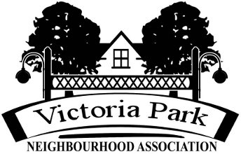

VPNA Spring 2025 Update

Here's the latest news from the Victoria Park Neighbourhood Association!

2025 VICTORIA PARK EARTH DAY CLEANUP

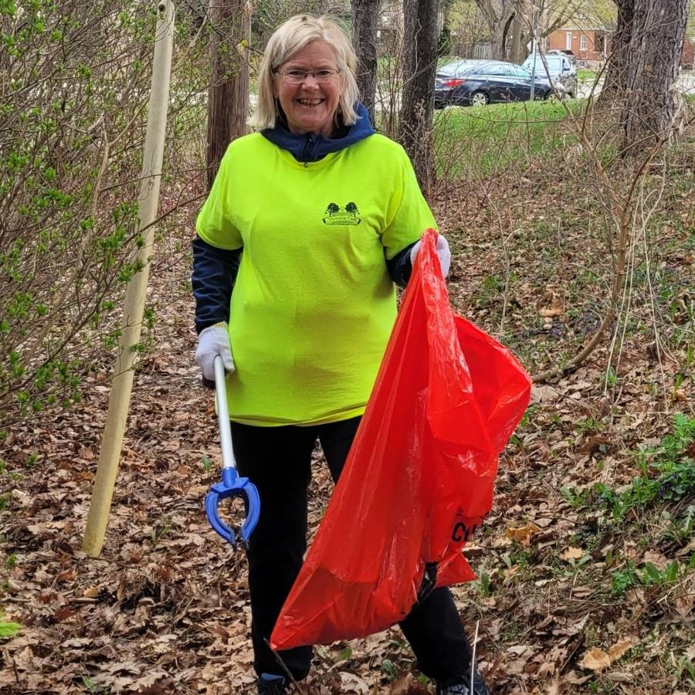

Thanks to all of you who were able to come out today with your families and neighbours, and to those who helped put up posters and promote this event in other ways! In total we had at least 25 people picking up litter in Victoria Park, along the Iron Horse Trail between Queen and West Ave.

VPNA PHOTO CONTEST!!

The Victoria Park Photo Contest is a fun opportunity for neighbours to put their creative skills to good use and celebrate all our park has to offer! Whether playing at the splash pad, picnicking with family, enjoying the gardens or just relaxing in Victoria Park, show us your favorite photo!​
AGE CATEGORIES
Under 12yrs
13yr-17yr
18+yrs
CATEGORY THEMES
Active Living
Nature
Family Time
Entry Regulations:
- Our photo contest is open to anyone who would like to participate to showcase their photo; however, to be eligible for prizing, particpants must reside within the boundaries of the Victoria Park Neighbourhood (click for our boundary map)
- Contest will run June 1 - Nov. 3, 2025 (last submission date)
- Only photos taken within Victoria Park will be considered for showcase and/or prizing
- Limit 1 photo per theme (multiple registrations are required with each additional entry)
- Age group is determined as of Nov 3, 2025
- Photos are only submitted by upload, through the registration on the left
- Photos will not be accepted by email
- Accepted files include: .jpg, .tif, .png ​​
- Photos should be labelled with your name and theme category​
Terms + Conditions:
- ALL images will be showcased at our AGM in November, where winners will be announced.
- In the interest of public safety & privacy, the VPNA reserves the right to decide which photos are shared on our website and/or social media platforms (Facebook/Instagram)
- Prize eligibility for residents of the Victoria Park Neighbourhood boundary
- The VPNA will not edit or enhance any images on behalf of the participant
- The VPNA is not liable or responsible for any photo sharing outside of our website and social page activity
- Members of the VPNA board may participate but may not be eligible for prizing​
Judging:
- Up to 3 Adult Judges - please apply at info@victoriaparkna.com
- Up to 3 12-17yr old Judges - please apply at info@victoriaparkna.com
READY TO SUBMIT YOUR PHOTO?
GO TO WWW.VICTORIAPARKNA.COM AND FILL OUT THE FORM ON "PHOTO CONTEST" TAB & UPLOAD YOUR DIGITAL PHOTO FILE!

VICTORIA PARK DEVELOPMENT COMMITTEE UPDATE

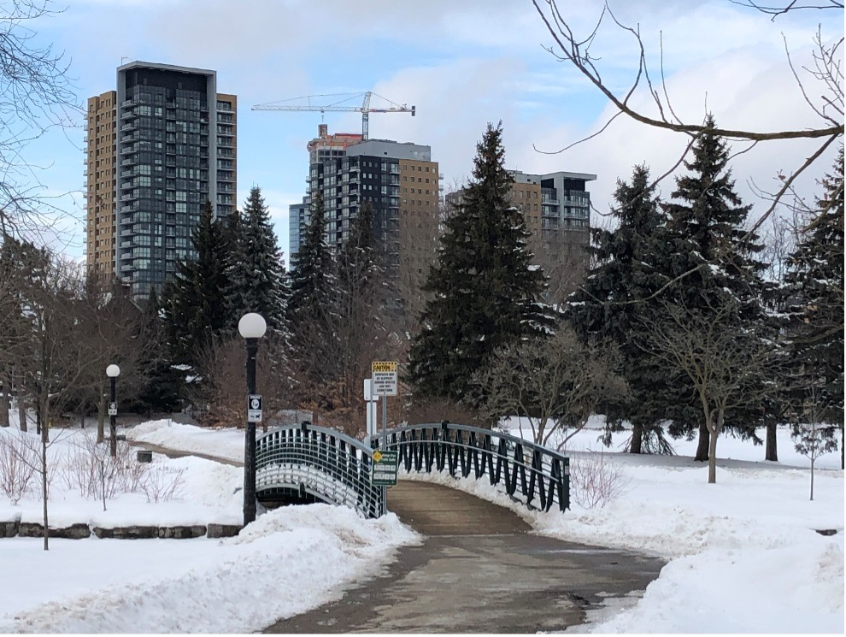

As reported in the Fall Newsletter, this sub-committee of the Board has been on hiatus since June 2024; three of five members have resigned, and two others have become very involved in a broader committee – Kitchener Citizens for Liveable Development (KCLD) – that brings together 8+ Downtown Kitchener (DTK) neighbourhoods to address DTK development issues.

At their February meeting, VPNA Board agreed the VPNA Development Committee should: exist on an Ad Hoc basis; come together as needed to address development issues specific to Victoria Park; and add other residents who are interested at the time. They also mandated Board Chair, Peggy Nickels, who is co-chairing KCLD to provide relevant updates on that group’s activities. Highlights are noted below.
Kitchener Citizens for Liveable Development (KCLD)
KCLD grew out of the previous Downtown Development Committee, led by Hal Jaeger, which brought together residents from primarily Downtown Kitchener (DTK) neighbourhoods to share network and information about development issues. The group morphed into KCLD last Spring and now includes active collaboration and advocacy on common concerns. Current focus areas include affordable housing, adequate green space and tree canopy, building with climate change in mind, and meaningful community engagement in the development process.
KCLD’s membership numbers a little over 80 residents, and includes mainly residents who live in 8+ neighbourhoods in and surrounding downtown Kitchener. One of the members from Cedar Hill neighbourhood was able to draw on the expertise of her partner toproduce a new logo!



The design and colour are intended to illustrate KCLD’s commitment to sustainable neighbourhoods that have a place for everyone, balanced with green space and trees.
The group has also just launched it’s own website, which is about to go public: https://sites.google.com/view/kitchener-citizens-4-liveable/kcld-home
Here you will find a wealth of information about development, both broadly and specific to Kitchener, including links to Provincial and Regional policies that affect development, Kitchener planning documents, more information about KCLD’s focus areas, and a blog.
One project that KCLD has been following closely and commenting on is Kitchener’s new Parks Master Plan that will guide the City’s parks and green space development over the next 20 years. The group delegated to City Council on May 26 and received excellent coverage in The Record. https://www.therecord.com/news/council/plea-for-more-downtown-green-space-as-kitchener-parks-plan-passes/article_11edd556-31c6-58fb-a511-8abba3d06001.html
In the coming months, they will continue to comment on the need to protect and build more affordable housing through the development and use of by-laws related to renoviction, rental replacement, short-term rentals, and inclusionary Zoning.

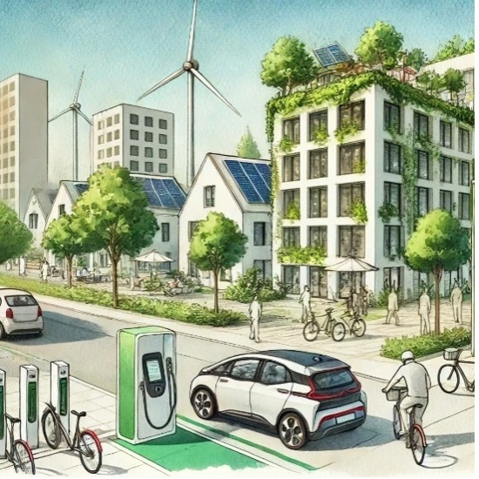

KITCHENER 2051 OFFICIAL PLAN REVIEW

What is Kitchener 2051?
How can the changes unfolding in our community over the next 25 years benefit everyone? The City of Kitchener is writing a new Official Plan called Kitchener 2051. The goal of Kitchener 2051 is about reflecting and implementing shared community priorities and directions. These priorities and directions will guide Kitchener’s development over the next 25 years and beyond in support of our vision of building a city for everyone where, together, we take care of the world around us and each other.
The City has created a Community Conversation Kit – a booklet designed to understand your thoughts and priorities through an interactive discussion with people in your community. This could be co-workers, community members, or neighbours – really any group that you would like to share ideas and have a conversation with. It works best in groups of 4-8. Your feedback on these will help shape the draft policies of the Official Plan.
Please take a look and consider using the kit in your organization. Detailed instructions are provided, and the first 50 people to submit a completed Conversation Kit will be reimbursed up to $30 for food! You can access the kit here: https://www.engagewr.ca/kitchener2051/community-conversation-kit
If you have any questions or would like support in using the Community Conversation Kit, please feel free to reach out to:
Elyssa Pompa (she/her), MES Pl., RPP, MCIP
Planner (Policy) | Planning and Housing Policy Division | City of Kitchener
519-783-8943| TTY 1-866-969-9994 | elyssa.pompa@kitchener.ca

VICTORIA PARK WORKING GROUP

As you may remember, this group, including two representatives from VPNA, attend these meetings with City staff to monitor and comment on the issues related to Victoria Park. Currently a large focus is on updating the Victoria Park Master Plan, which guides the park’s maintenance and development over periods of 10 years. During May, Working Group members have participated in a “walk and talk” tour of the park, a workshop focused on discussing and generating ideas of how the park could be improved to meet such challenges as increasing population and climate change, and a resident consultation drop-in at the Pavilion. Please make time to provide your feedback at https://www.engagewr.ca/VictoriaParkMP
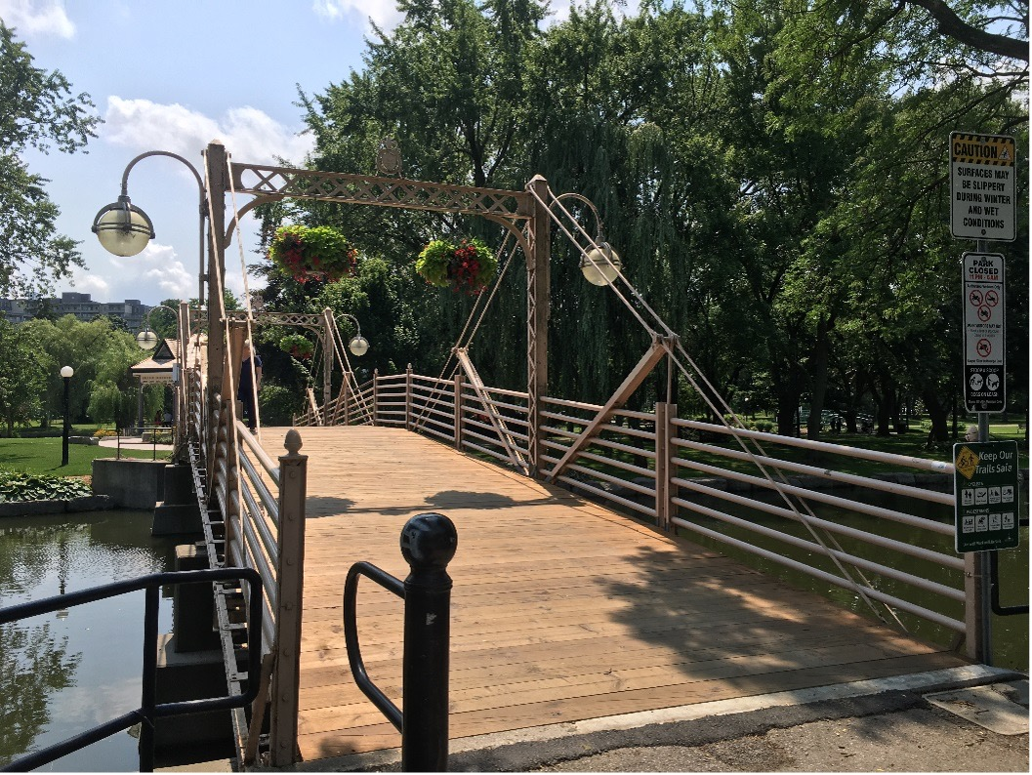
The VPNA has brought to the Working Group their concern about the unsafe crossing at Jubilee and Park St. This crossing is at the bottom of a hill and a sharp bend in the road as Park becomes Jubilee Drive, where pedestrians struggle to cross safely. Both groups are now discussing how the new Victoria Park Master Plan might introduce a safe crossing in that area.
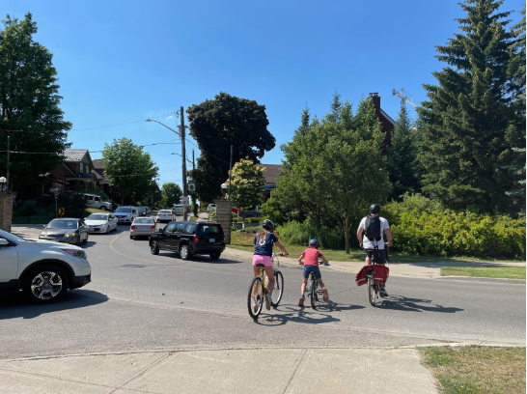
The VPWG also had a presentation from Kitchener’s Sanitary and Stormwater Utilities department to learn more about their plans for mitigating flood risks due to climate change. VPNA had recently learned that a flood mitigation project for the Clock Tower field had been deferred from 2026 to 2036, due to cost and wanted to know more about how the City planned to offset that loss. Staff have been very receptive to additional meetings to discuss possible options. We will keep you informed via this newsletter about future progress.

COMMENT ON KITCHENER'S PROCESS OF COMMUNITY ENGAGEMENT


Seat At The Table is your opportunity help shape and improve how Kitchener engages with you in future city decision-making.

https://www.engagewr.ca/AtTheTable
Community engagement can be defined as: “An intentional process to include people in inclusive and respectful ways to shape decisions, actions, impacts, or change.” During Kitchener’s 2023-2026 strategic planning engagement process, residents said they want to take part in city decision-making and know their input makes a difference. Comments included:
- Make engagement easy to understand and convenient to take part in;
- Use many different ways to listen to and involve residents;
- Everyone, including people of all ages, should be part of the conversation;
- Don’t ask people to contribute if you’ve already made the decision;
- Explain the decision-making process and show how resident contributions were considered;
- Listen to us on a more regular basis, including in-between projects
- Do more to reach people and promote opportunities to take part

KITCHENER TRAIL TRASH

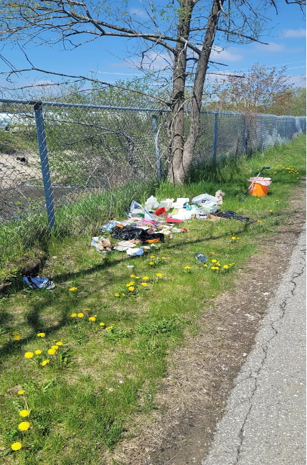

https://www.facebook.com/61575765151548
Don is a civic-minded neighbour who has been cleaning up litter since he and his wife moved here a couple of years ago. He could use some help! If you’re interested, check out his new facebook page and let him know!

COMEUNITY ROOTS GARDEN UPDATE

For those of you who are not familiar with us, we are a community garden that operates differently then most! We work together, to learn and share knowledge, the workload and the harvest. We also donate to organizations that help feed those in need and we take care of a food forest adjacent to the garden.
ComeUnity Roots Garden is off to a decent start this year considering a few months ago we had almost no gardeners and a lot of work ahead of us!
We hosted a garden orientation and shared our information through local Grassroot organizations, which resulted in a much fuller crew of helpers on board for the season.
We are hoping to start planting May 31st!
If you are interested to join us as a: volunteer, gardener and/or steward for our food forest please contact us at comeunityrootsgarden@gmail.com or through our Facebook @comeunityrootsgarden

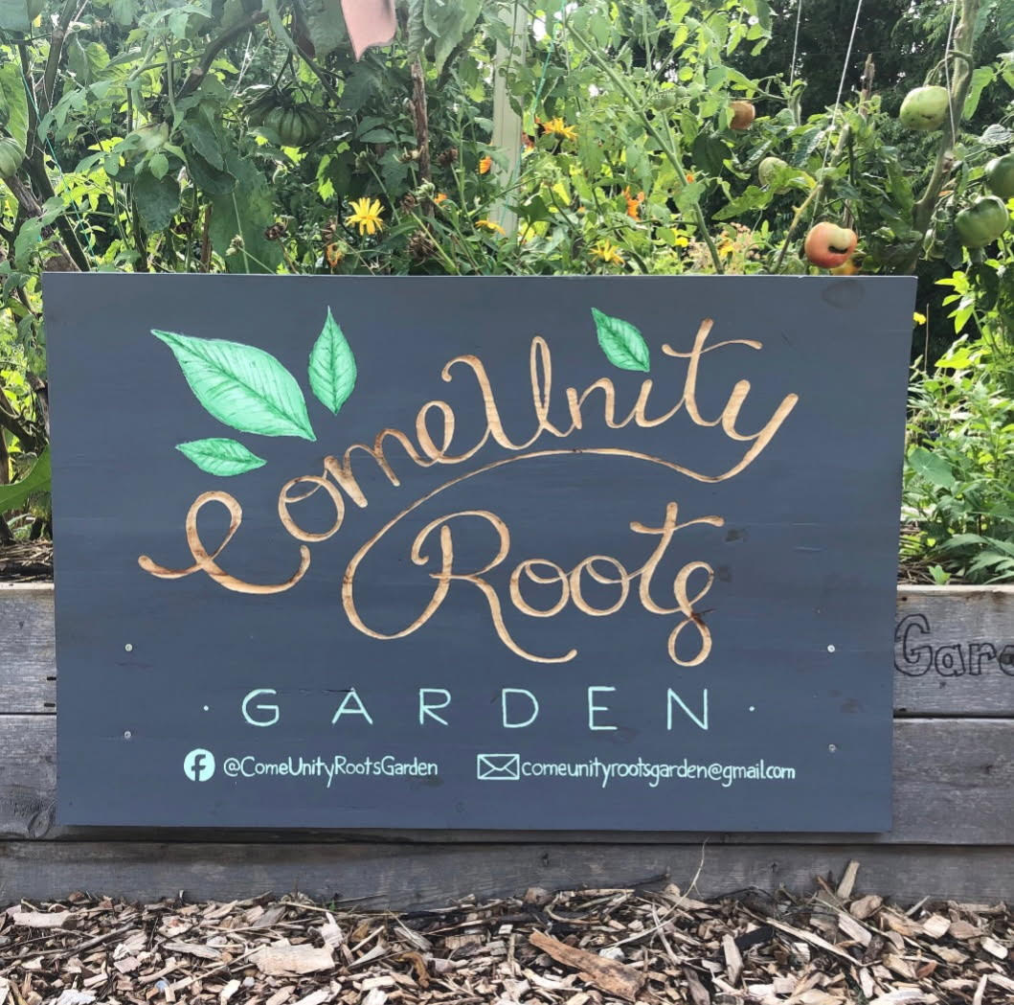

A NOTE FROM OUR COUNCILLOR - WARD 9



Well, we’ve survived two elections over the past six months. It’s nice to have the summer off.
Activities abound in Ward 9 during the summer months. Outdoor patios are open, live music is performed in the square, in Vogelsang Green and along King St. The usual annual festivals will be returning such as Blues Festival, Multicultural and Rib Fest. Caribana promises to be bigger and better, and The Way Back and Pickleball Festivals will also return. None of these events could happen without the help of hundreds of volunteers! Check www.kitchener.ca/volutneer to find out how to apply. I hope to see you at some of these upcoming events.
Watch for two of my favourite biannual summer events: MT Space’s Impact Festival and CAFKA public art displays.
Speaking of volunteers, I want to thank everyone who volunteered their time over the winter and spring months. Without your help things would be very different. A special thankyou to the Victoria Park Neighbourhood Association and Victoria Park Working Group volunteers who put in endless hours organizing events and programs and keeping residents informed about city business.
Council recently updated Kitchener’s fireworks bylaw to further restrict the use of fireworks on Victoria Day and Canada Day to between 9 and 11pm and on Diwali 8 to 10pm. Fines have increased from $300-$400 to $1,000 and $1500. The city will ban the sale of fireworks in Kitchener starting in 2026. Given the challenges experienced by residents in and around Victoria Park last year, staff will continue to ensure safety in the park this year. Hopefully, this update to the bylaw will make these festivities safer for everyone. My amendment calling on the city to transition away from city-run fireworks displays to alternatives such as drones or light shows, was not approved.
Contact me with your ideas or concerns at debbie.chapman@kitchener.ca or call me at 226-752-7104. I am always happy for the opportunity to assist the residents of my ward.
Councillor Debbie Chapman―Ward 9

Copyright © 2020 *VPNA, All rights reserved.
Our mailing address is:
35B Weber St W
Kitchener, ON
N2H 3Z1
unsubscribe from this list update subscription preferences

This email was sent to << Test Email Address >>
why did I get this? unsubscribe from this list update subscription preferences
Victoria Park Neighbourhood Association · c/o Downtown Community Centre · 35B Weber St. W · Kitchener, On N2H 3Z1 · Canada


